**GCP-BASED GAMING INFRASTRUCTURE**

**By: Ram Nath**

This **Google Cloud Platform (GCP)-Based Online Gaming Infrastructure** is designed to meet critical requirements such as scalability, low latency, security, high availability, and more. This architecture leverages various GCP services and best practices to ensure a robust, secure, and efficient gaming platform. Below are detailed notes on how each requirement is addressed within the designed solution.

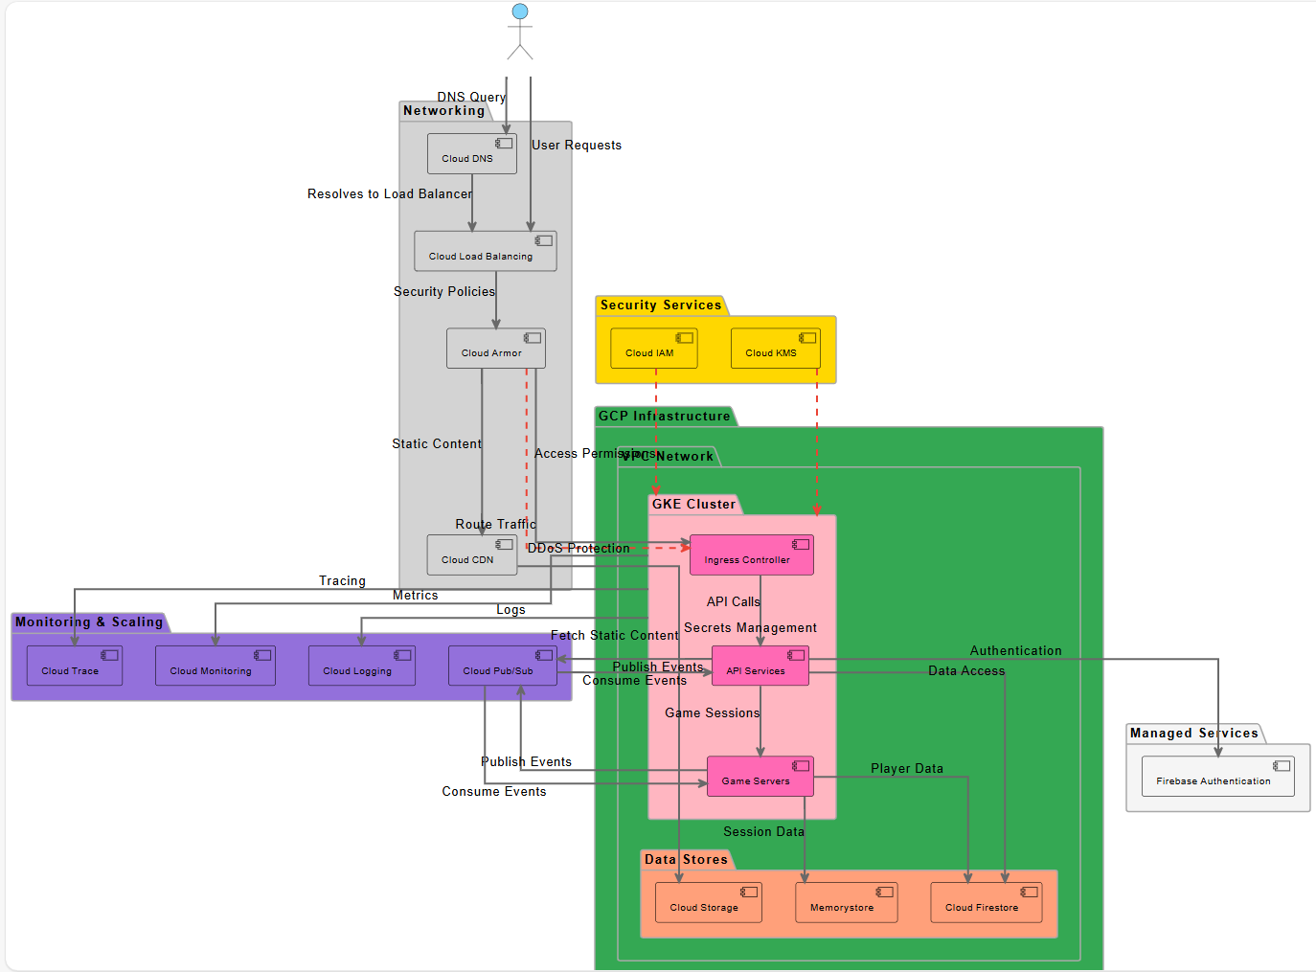

**Fig - 01**

**Architectural Design and Requirements Fulfillment**

**1. Scalability**

* **GKE Cluster (Google Kubernetes Engine):**
  + **Container Orchestration:** Utilizes GKE for managing containerized applications, allowing automatic scaling based on demand.
  + **Auto-Scaling:** GKE can automatically adjust the number of nodes in the cluster, ensuring resources match the current load.
* **Cloud Load Balancing:**
  + Distributes incoming traffic across multiple instances, ensuring no single instance becomes a bottleneck.
  + Supports scaling up or down seamlessly as player demand fluctuates.
* **Cloud Pub/Sub:**
  + Facilitates scalable messaging between API Services and Game Servers, handling high volumes of events without performance degradation.

**2. Low-Latency Gameplay**

* **Cloud CDN (Content Delivery Network):**
  + Caches static content closer to players, reducing latency and improving load times.
* **Memorystore:**
  + Provides in-memory data storage for session data, enabling rapid access and updates essential for real-time gameplay.
* **Cloud Firestore:**
  + Offers low-latency, scalable NoSQL database services for storing player data and game state.

**3. Security**

* **Cloud Armor:**
  + Protects against DDoS attacks and enforces security policies to safeguard the infrastructure.
* **Cloud IAM (Identity and Access Management):**
  + Manages access permissions, ensuring that only authorized entities can interact with various components.
* **Cloud KMS (Key Management Service):**
  + Secures sensitive data by managing encryption keys for secrets management within the GKE Cluster.
* **Firebase Authentication:**
  + Provides secure authentication mechanisms for players, integrating seamlessly with API Services.

**4. High Availability**

* **Cloud Load Balancing & Cloud CDN:**
  + Ensures traffic is evenly distributed and content is highly available across multiple regions.
* **GKE Cluster:**
  + Deploys game servers across multiple nodes and zones, providing redundancy and minimizing downtime.
* **Cloud Firestore & Cloud Storage:**
  + Offer highly available data storage solutions with automatic replication across regions.

**5. Data Storage & Archival**

* **Cloud Firestore:**
  + Stores structured player and game data with high availability and scalability.
* **Cloud Storage:**
  + Handles the storage of static assets, such as game resources and user-generated content, with lifecycle management for archival.
* **Memorystore:**
  + Provides fast access to session data, while Cloud Storage can be used for longer-term archival needs.

**6. Container Orchestration**

* **Google Kubernetes Engine (GKE) Cluster:**
  + Manages deployment, scaling, and operation of containerized applications (API Services and Game Servers).
  + Facilitates rolling updates and self-healing capabilities to maintain application health.

**7. Logging & Monitoring**

* **Cloud Monitoring:**
  + Tracks performance metrics across the infrastructure, enabling proactive management and optimization.
* **Cloud Logging:**
  + Collects and analyzes logs from various components, aiding in troubleshooting and maintaining operational insights.
* **Cloud Trace:**
  + Provides distributed tracing to monitor and debug latency issues within API Services and Game Servers.

**8. Notifications**

* **Cloud Pub/Sub:**
  + Serves as the messaging backbone, enabling real-time notifications and event-driven communication between services.
  + Facilitates the publishing and subscribing of events for actions like in-game events, player notifications, and system alerts.

**9. DDoS Attacks**

* **Cloud Armor:**
  + Implements security policies specifically designed to detect and mitigate DDoS attacks, ensuring the platform remains resilient under attack.

**10. Self-Healing Infrastructure**

* **GKE Cluster:**
  + Automatically restarts failed containers and reschedules them on healthy nodes, maintaining application availability without manual intervention.
* **Cloud Load Balancing:**
  + Redirects traffic away from unhealthy instances, ensuring continuous service availability.

**11. Effective Distribution of Load**

* **Cloud Load Balancing:**
  + Efficiently distributes incoming traffic across multiple instances and regions, preventing overload on any single component.
* **Ingress Controller:**
  + Manages external access to services within the GKE Cluster, ensuring balanced and optimized traffic routing.

**Detailed Component Breakdown**

**Players and Networking**

* **Players:**
  + Represented as actors interacting with the system through devices.
* **Networking Components:**
  + **Cloud DNS:** Resolves domain names to IP addresses, directing player requests appropriately.
  + **Cloud Load Balancing:** Distributes incoming player traffic to various backend services.
  + **Cloud CDN:** Caches and delivers static content efficiently to reduce latency.
  + **Cloud Armor:** Protects against malicious traffic and enforces security policies.

**Security Services**

* **Cloud IAM & Cloud KMS:**
  + Ensure secure access and manage encryption keys, safeguarding the integrity and confidentiality of data and services.

**GCP Infrastructure**

* **VPC Network:**
  + Provides a secure and isolated network environment for all services.
* **GKE Cluster:**
  + Hosts the containerized API Services and Game Servers, enabling efficient management and scaling.
* **Data Stores:**
  + **Cloud Firestore:** Manages player and game data.
  + **Cloud Storage:** Stores static assets and supports archival.
  + **Memorystore:** Handles in-memory session data for rapid access.

**Managed Services**

* **Firebase Authentication:**
  + Offers seamless and secure user authentication integrated with the gaming platform.

**Monitoring & Scaling**

* **Cloud Monitoring, Logging, and Trace:**
  + Provide comprehensive visibility into system performance, facilitating proactive maintenance and optimization.
* **Cloud Pub/Sub:**
  + Enables scalable and reliable messaging between services, supporting real-time notifications and event handling.

**Diagram Relationships and Data Flow**

* **Player Interactions:**
  + Players send DNS queries to **Cloud DNS**, which resolves to **Cloud Load Balancing**.
  + **Cloud Load Balancing** directs user requests to appropriate backend services, protected by **Cloud Armor**.
* **Security and Routing:**
  + **Cloud Armor** enforces security policies and routes traffic either to **Cloud CDN** for static content or to the **Ingress Controller** for dynamic requests.
* **API Services and Game Servers:**
  + The **Ingress Controller** manages API calls, which interact with **Firebase Authentication** for user verification and **Cloud Firestore** for data access.
  + Game Sessions are handled by **Game Servers**, which utilize **Memorystore** for session data and **Cloud Firestore** for player data.
* **Monitoring and Logging:**
  + The **GKE Cluster** sends metrics to **Cloud Monitoring**, logs to **Cloud Logging**, and tracing data to **Cloud Trace** for comprehensive observability.
* **Messaging with Cloud Pub/Sub:**
  + Both **API Services** and **Game Servers** publish and consume events through **Cloud Pub/Sub**, enabling real-time communication and notifications.
* **Security Measures:**
  + Dashed lines indicate security-related connections, such as DDoS protection via **Cloud Armor**, access permissions through **Cloud IAM**, and secrets management with **Cloud KMS**.

**Conclusion**

The designed GCP-based online gaming infrastructure effectively addresses all specified requirements through a combination of scalable services, robust security measures, efficient data management, and comprehensive monitoring. By leveraging GCP's managed services and container orchestration capabilities, the architecture ensures low-latency gameplay, high availability, and resilience against attacks. Additionally, the use of Infrastructure as Code principles facilitates consistent and automated deployments, further enhancing the system's reliability and maintainability.